Minutes of Phone Call

Date: Monday 23/04/2018

Time: 15.30

Attendees: Niall Collins and Michael Russell

Where: Phone Call

**Discussed during Phone Call…**

1. Looking at User guide on Android Studio
2. Get in touch with David Scoot in relation to using masters available room for the use of a PC
3. Write-Up

* Page Numbers
* 1.5 spacings
* Right and Left justification
* Chapter and Section Numbers
* New Chapter at the start of every page
* Re-write User stories
* Acceptence criteria to start with “*Verify”*
* Don’t speak from the how speak about what im going to do
* Speak from business side of things not functionality

1. Research

* Talk about 3-4 Apps that currently use Geo-Fencing

**Work to do this week…**

My plan this week is to get my project transferred onto a Machine which meets the requirements of Android studio; as you can see below from *fig 1.1* these are the system requirements from Android Studio to run on a machine; as can be seen from *fig 1.2* this is not the case from my machine as straight away the system requires a minimum of 3GB to run android and a furthere 1GB to run the Emulator which the machine I am using only has a total availabe of 3.6GB, it also requires 2GB min of free disk space this is only the case for me when I have not downloaded any emulator API which in turn will not meet these requirements also.

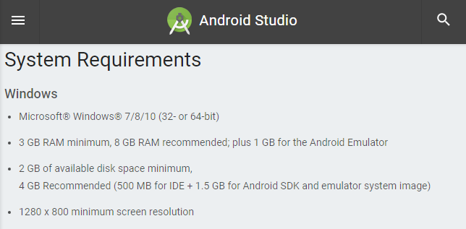

***Fig 1.1***

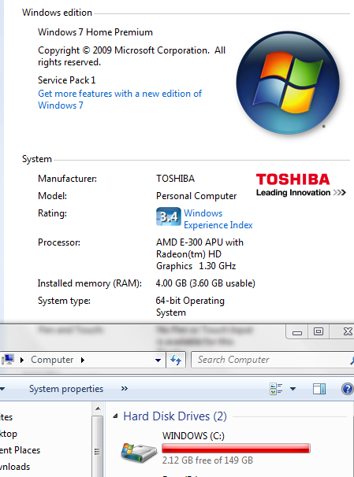

***Fig 1.2***

**Write-Up**

|  |  |  |
| --- | --- | --- |
| ***Plan to do*** | ***% Complete*** | ***Hours to completion*** |
| Intrduction | 0 | 2 |
| Research | 70 | 3 |
| User stories | 80 | 3 |
| *Architecture and design* | 80 | 3 |
| *Test and code examples* | 0 | 5 |
| *Future work and conclusion* | 0 | 5 |
| ***Total*** | **38%** | **21hrs** |

**Enviroment**

|  |  |  |
| --- | --- | --- |
| **Plan to do** | **% Complete** | **Hours to completion** |
| Write test code(Hello World) | 100 | 0 |
| Load test code to Enviroment | 0 | 1 |
| **Total** | **50%** | **1hr** |

**Code Implementation**

|  |  |  |
| --- | --- | --- |
| **Plan to do** | **% Complete** | **Hours to completion** |
| Login page | 90 | 1 |
| Create account page | 90 | 1 |
| Geo-Fence code | 0 | 15 |
| Log for stored locations | 0 | 3 |
| Push Notifications | 0 | 2 |
| Search bar | 0 | 1 |
| Databases | 0 | 3 |
| Testing | 0 | 4 |
| **Total** | **22.5%** | **30hrs** |